SIMATS ENGINEERING (SAVEETHA SCHOOL OF ENGINEERING)
Department of Computer Science and Engineering
CO1_AT2 — DATA INTERPRETATION EXERCISE
Course Code: | DSA0606 | Course Title: | Data Handling and Visualization
CO Assessed: | CO2 – Development (BL4) | Assessment: | Assessment Tool 2 – Visualization  Development
Weightage: | 20% of CIA | Total Marks: | 25 (5 Questions × 5 Marks)
CO1 Statement: | Analyze and synthesize multiple data views into a coherent, annotated dashboard that  communicates a clear narrative insight. (BL4)
Student Name: | Bagya Vennkatesh | Reg. No.: | 1923242643
Section / Batch: | 2023 | Date: | 04-08-2026

Problem 1 — Retail Quarterly Dashboard (5 Marks)
Data: Quarterly revenue and profit margin: Q1 = $200k / 15%, Q2 = $250k / 18%, Q3 = $220k / 12%, Q4 =
$300k / 20%.
Task: Build a two-chart dashboard: a bar chart of revenue and a line chart of profit margin, aligned on
the same quarter axis. Add one annotation highlighting the quarter with the highest margin, and write a one-sentence takeaway summarizing the overall trend.

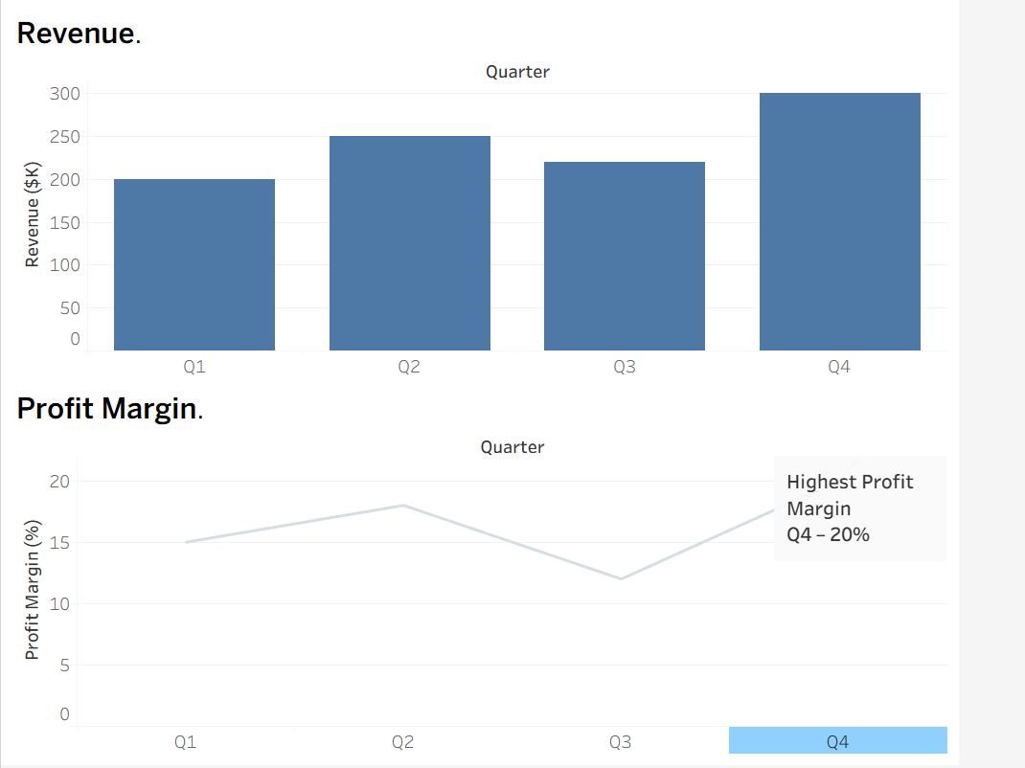
Problem 22 — Real Estate Market Dashboard (5 Marks)
Data: Median home price and days-on-market by neighborhood: Riverside = $450k / 20 days, Hillside =
$600k / 45, Downtown = $700k / 15, Suburbs = $350k / 60, Lakeside = $800k / 25.
Task: Build a dashboard with a bar chart of median price and a bar chart of days-on-market for the same
neighborhoods. Annotate the neighborhood with the strongest buyer demand (low days-on-market
despite high price), and write a takeaway for a home buyer.
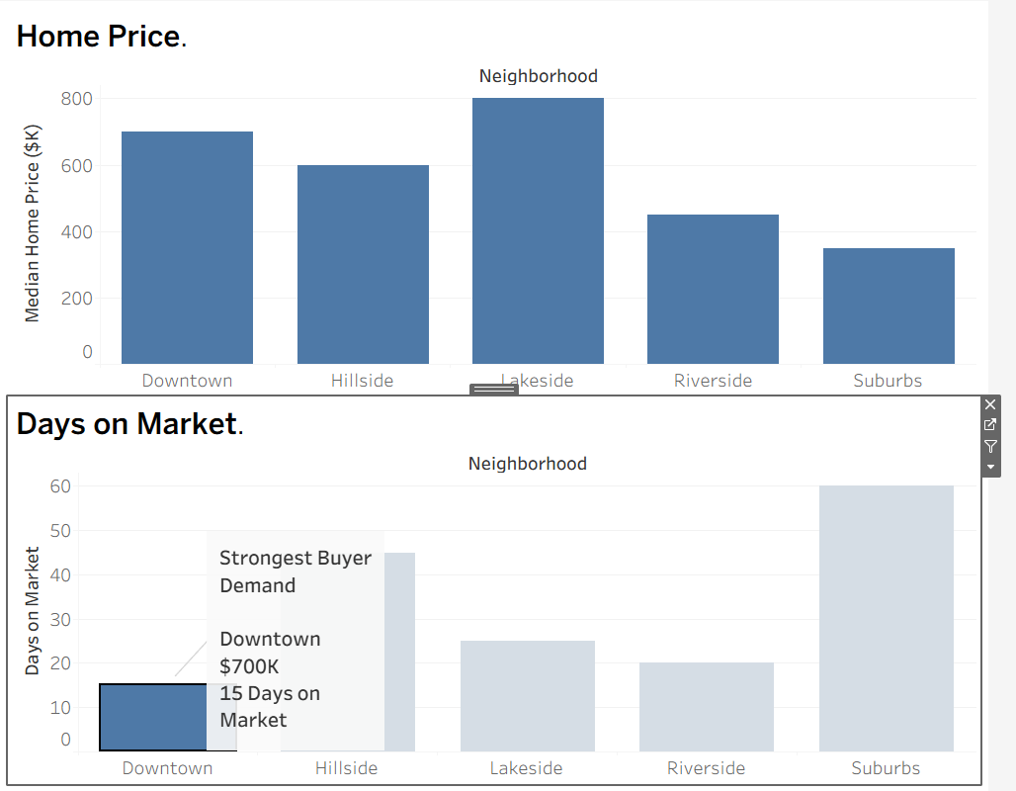

Downtown has the strongest buyer demand, as homes sell quickly (15 days) despite having a high median price of $700K, while Suburbs offer the lowest prices but require the longest selling time.
Problem 23 — Fitness App Cohort Dashboard (5 Marks)
Data: Retention rate at week 1 / 4 / 8 / 12 for three signup cohorts: Jan cohort = 100%,70%,50%,35%;
Feb cohort = 100%,65%,40%,20%; Mar cohort = 100%,75%,60%,50%.
Task: Build a dashboard with a multi-line chart showing retention curves for all three cohorts across the
four checkpoints. Annotate the cohort with the steepest drop-off, and write a narrative recommending
the best point to intervene.
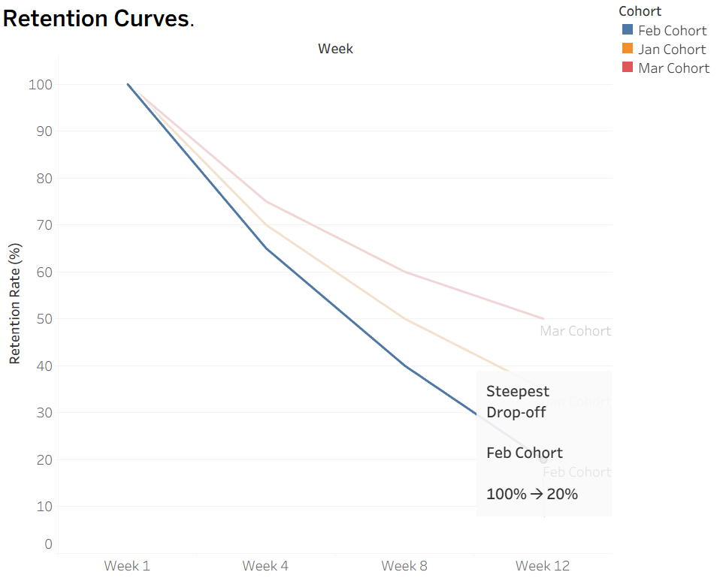

The February cohort experienced the steepest decline in user retention. The best time to intervene is before Week 4 by introducing personalized reminders, rewards, or engagement campaigns to improve long-term retention.
Problem 24 — Weather Storm Tracking Dashboard (5 Marks)
Data: Hourly wind speed (km/h) and barometric pressure (hPa) over 12 hours: wind =
40,45,55,70,90,110,105,85,60,45,35,30; pressure =
1005,1002,998,992,985,978,980,988,995,1000,1003,1006.
Task: Build a dashboard with a line chart of wind speed and a line chart of pressure on the same hourly
axis, stacking the two charts vertically to avoid a dual y-axis. Annotate the peak-intensity hour, and write
a narrative describing the storm's progression.
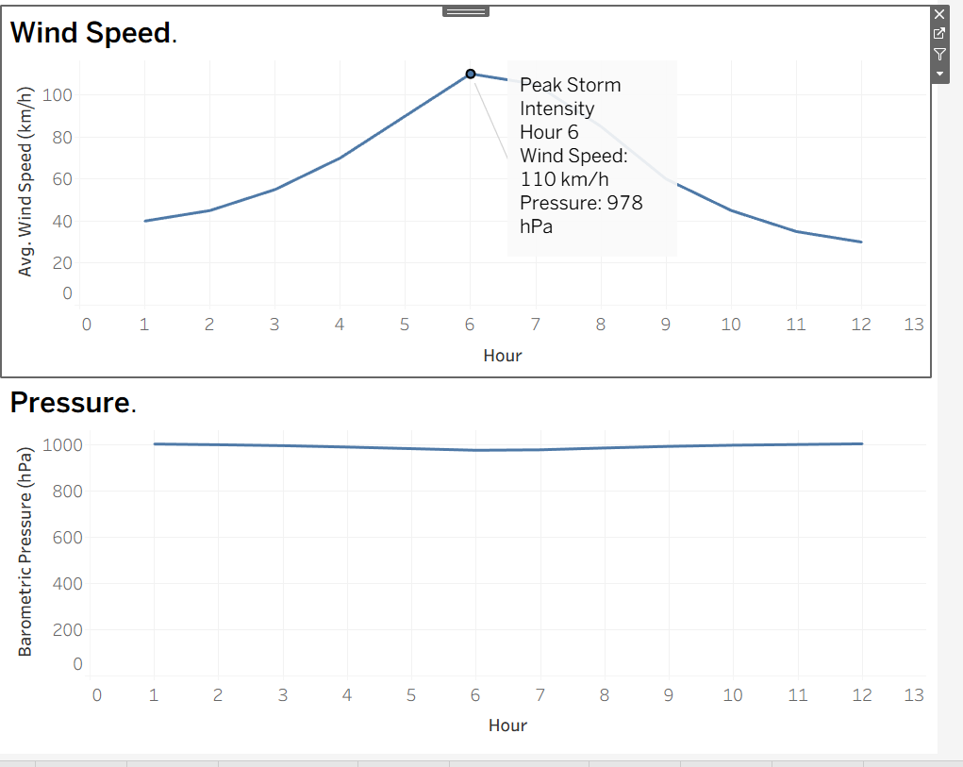
The storm strengthened from Hour 1 to Hour 6 as wind speed increased from 40 km/h to 110 km/h while barometric pressure dropped from 1005 hPa to 978 hPa. After Hour 6, wind speed decreased and pressure increased, indicating that the storm gradually weakened.

Problem 25 — Company-Wide KPI Dashboard (5 Marks)
Data: Revenue ($M), customer count (thousands), and employee count over 4 years: Revenue =
10,15,22,30; Customers = 50,80,120,180; Employees = 40,55,70,95.
Task: Build a small-multiples dashboard with three aligned mini-charts (one per metric) sharing the same
year axis. Annotate any year where growth patterns diverge across the three metrics, and write an
executive-level narrative summary of the company's 4-year trajectory.
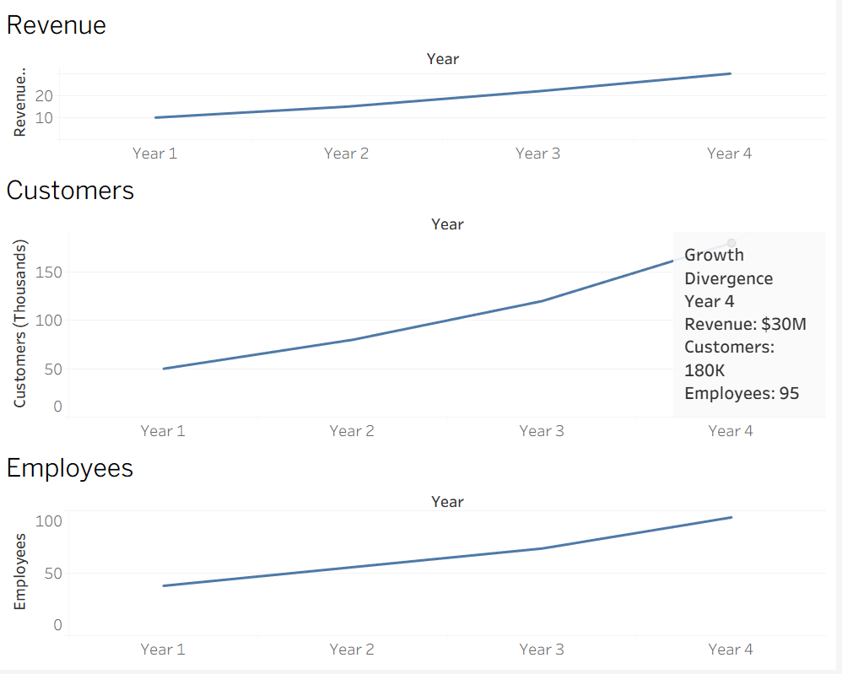

Over the four-year period, ABC Technologies achieved consistent growth in revenue, customer base, and workforce. Year 4 shows the strongest business expansion, with customer growth outpacing employee growth, indicating improved operational efficiency and successful business scaling.

